Vishwakarma Institute of Technology
Department of Computer Engineering
A.Y. 2025-26 (Sem II)
Course: Design and Analysis of Algorithms
Tutorial 10: Problem Solving

- A bracelet is made up of 2n black and 2n white beads. Prove that we can cut a portion of the bracelet that has exactly n white and n black beads. By cutting a portion of bracelet it is understood we cut the bracelet at two positions and partition it into two contiguous portions.
For example, if we cut the bracelet at two positions, one from each dotted section in the picture, we get two contiguous portions, one containing two black and two white beads and the other containing three black and three white beads. (Note that for full credit you must give concrete proof, vague/incomplete arguments don’t carry any weightage)
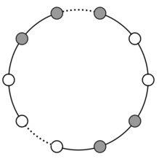
- A binary tree is called full if every node has zero or two children. Let f(n) denotes number of full binary trees with n+1 leaf nodes. For example, f(1) = 1 as there is only one full binary tree with two leaf nodes (root node with left and right child), f(2) = 2 as there are two different full binary trees with 3 leaf nodes (root with a left and right child and one of these left or right child has two children).
Obtain a recurrence relation for f(n). Use the above recurrence relation or any other method to find f(7)

